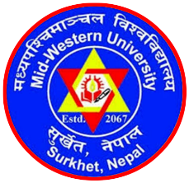 | MID-WESTERN UNIVERSITY, FACULTY OF MANAGEMENT  Birendranagar, Surkhet, Nepal  MPhil, PhD and Post-Doctoral Programs in Management  Admission Process/Schedule
SN | Activities | Deadlines
1. | Soliciting applications for admission | January 5, 2020 – January 31, 2021
2. | Eligibility screening and publication of the candidates | February 3, 2021  [Publication in University website]
3. | Conduction of computer-based, time-bound, online entrance examinations | February 6, 2021  [8:00 AM to 1:00 PM]
4. | Publication of results of the entrance examinations and schedule for personal interviews | February 8, 2021  [5:00 PM Nepali Time on University website]
5. | Personal interviews on MS Zoom, or in-person attended form | February 10-11, 2021  [Individual schedule will be provided]
6. | Publication of final results of the entrance test with call for admission | February 12, 2021  [5:00 PM Nepali Time on University website]
7. | Admission close | February 19, 2021

