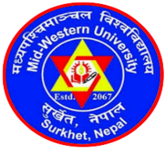 | MID-WESTERN UNIVERSITY FACULTY OF MANAGEMENT  Birendranagar, Surkhet, Nepal  Notice of Admission Open for 2021 Session  MPhil, PhD and Post-Doctoral Programs in Management  [First publication: January 5, 2021]

The MPhil, PhD and Post-Doctoral Research Committee of the Mid-Western University Faculty of Management invites applications/proposals from the interested candidates for the admission in 2021 session.
Master of Philosophy (MPhil), Doctor of Philosophy (PhD) and Post-Doctoral programs of Mid-Western University Faculty of Management have been designed with an aim to equip the aspiring scholars, leaders and policy thinkers for the collective attainment of goals leading to national prosperity and wellbeing.
Please log on www.mwufom.edu.np for detailed information, contact: 9851105671, 9841541521. Email address for document submission: sharmagaire@gmail.com or rijalcpr@gmail.com

