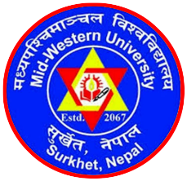 | MID-WESTERN UNIVERSITY FACULTY OF MANAGEMENT  Birendranagar, Surkhet, Nepal  Eligibility Criteria for Admission
Criteria | Programs
 | MPhil | PhD | Post-Doctoral
- Academic qualification | Master’s degree in management with at least 50% or 2.50/4.00 CGPA. | MPhil in management with at least 60% or 3.00/4.00 CGPA. | PhD in management within last 5 years.
- Years of formal education | 18 years or 16 years + at least 2 years work experience | 19.5 years or 1.50 years + at least 2 years work experience
- Work experience | - No work experience required for at least 80% or 3.50/4.00 CGPA in master’s degree.  - One-year post-master’s degree work experience required for at least 60% or 3.00/4.00 CGPA in master’s degree.  - Two-year post-master’s degree work experience required for at least 50% or 2.50/4.00 CGPA in master’s degree. | No work experience is required after the completion of MPhil degree.
- Academic publications | Desirable but not mandatory: Upto 2 articles published in referred journals during or after the completion of master’s degree. | At least 3 articles published in referred journals during or after the completion of MPhil degree. | At least 5 articles published in referred journals after the completion of PhD degree.
- Language proficiency | Specialist level proficiency of English language required in writing and presentation. | Expertise level proficiency of English language required for research writing, publication, and presentation. | Expertise level English language proficiency required for research writing, publication and presentations
- Computing | General computing skill is highly preferred. | Proficient in operating a few data processing softwares and producing reports. | Proficient in operating a few data processing softwares and producing reports.

